SUMMER INTERNSHIP REPORT

On

**BRAIN TUMOR DETECTION USING IMAGE PROCESSING IN MATLAB**

 

**Submitted By**

**Ipshita**

B.Tech(III year)

Electronics & Communication Engineering

**Banasthali Vidyapith, Rajasthan**

**Internship Period**

(15th May to 30th June 2024)

Under the Guidance of

**Dr. Dharamraj Sc ‘F’**

at

**Regional Centre for Military Air Worthiness(RCMA)**

**Defense Research & Development Organisation**

**Ministry of Defense, Government Of India**

**ACKNOWLEDGEMENT**

I am highly obliged to R.D Mr Vinod Kumar Sc ‘F’, RCMA Lucknow, for allowing me to associate with this esteemed establishment and I am thankful to Dr. Dharamraj Sc ‘F’ and Er.B Singh Sc ‘E’ for helping me throughout my internship as summer trainee in ‘RCMA’ for 6 weeks period from 15th May to 30th June 2024.

I am extremely grateful to all those who have helped me for the successful completion of my training at RCMA, HAL, Lucknow Division.

Working in project “**Brain Tumor Detection Using Image Processing in MATLAB** ” has certainly been a good learning experience and has reinforced my knowledge of image processing to a great deal.

**Ipshita**

(B.Tech, Electronics & Communication Engineering)

(Banasthali Vidyapith, Rajasthan)

**CONTENTS**

1. About RCMA.
2. Abstract.
3. MATLAB
4. MATLAB Tools.
5. Features of MATLAB
6. Image Processing.
7. Techniques of Image Processing.
8. Operations on Images.
9. Applications of Image Processing

10. Image Processing in MATLAB

11. Brain Tumor Detection

12. Brain Tumor Detection using Image Processing

13. MATLAB Code

14. Procedure of the Project

15. Results

16. Reference

**1. About RCMA**

RCMA (Lucknow) is responsible for Airworthiness Certification of accessories during design, development, production, repair and overhaul. Centre for Military Airworthiness & Certification (CEMILAC) is one of the premier establishments of Defense Research and Development Organisation (DRDO).

CEMILAC gives Airworthiness certification to Indian Airborne Platforms. The airborne platform can be Aircraft, Helicopter, unmanned Aerial vehicle, and Aerostats. Each system, Line Replaceable unit (LRU), component, material and the software which goes into airborne platform of Indian Military needs to be certified. RCMA comes under DRDO (Defense Research and Development Organization) DRDO is the R&D wing of Ministry of Defense, Govt. of India, with a vision to empower India with cutting-edge defense technologies and a mission to achieve self-reliance in critical defense technologies and systems, while equipping our armed forces with state-of-the-art weapon systems and equipment in accordance with requirements laid down by the three Services.

DRDO was formed in 1958 from the amalgamation of the then already functioning Technical Development Establishment (TDEs) of the Indian Army and the Directorate of Technical Development & Production (DTDP) with the Defense Science Organization (DSO). DRDO was then a small organization with 10 establishments or laboratories. Over the years, it has grown multi-directionally in terms of the variety of subject disciplines, number of laboratories, achievements and stature.

**2. Abstract**

In today’s world, Cancers have been very common. Especially Brain tumors, so early identification and treatment of a tumor is essential as it typically spreads to other tissues, decreasing the chances of effective therapy and survival. Therefore, to detect these tumors in a more fast and efficient way I created a GUI to detect tumors using image processing in MATLAB by following several procedures such as image filtering, feature extraction, edge detection, etc. Finally, it was classified whether the image has tumor or not.

**3. MATLAB**



**Fig 1. MATLAB Logo**

MATLAB stands for Matrix laboratory. It was designed by Cleve Moller and developed by MathWorks. It is a multipurpose programming language for numerical computation. MATLAB has features such as built-in editing, debugging tools, and data structure. It has easy-to-use graphic commands and various built-in commands and math functions that enable users to perform mathematical calculations. This software allows users to manipulate matrices, run algorithms, design user interfaces, and visualize multiple functions and data types. It is used for signal processing, image and audio processing, machine learning, and [deep learning.](https://www.spiceworks.com/tech/artificial-intelligence/articles/what-is-deep-learning/) Further, errors in MATLAB are easy to fix as it is not a compiled language but an interpreted one.

**Features of MATLAB**

1) High-level language.

2) Interactive environment.

3) Interfacing with different languages.

4) Mathematical function library.

5) Broad platform compatibility.

6) Parallel and distributed computing.

7) Machine learning and deep learning.

8) Simulink integration.

9) Data import/export and connectivity.

**4. MATLAB Tools**

In MATLAB, "tools" generally refer to various features, functionalities, or companion applications that extend the core capabilities of the software. These tools are designed to aid in specific tasks such as data analysis, visualization, signal processing, and more. Here are some common MATLAB tools:

* **MATLAB Editor**: This is where you write and edit MATLAB code. It includes syntax highlighting, debugging tools, and integration with the MATLAB workspace.
* **MATLAB Command Window**: It allows you to interactively execute MATLAB commands and see their results immediately.
* **MATLAB Live Editor**: Provides an interactive environment where you can combine MATLAB code with formatted text, equations, and visualizations in a single document.
* **MATLAB Apps**: These are interactive graphical applications that provide specialized workflows for tasks such as curve fitting, image processing, control system analysis, and more. Examples include the Curve Fitting Tool, Image Processing Toolbox, and Control System Designer.
* **Simulink**: Although technically a separate product, Simulink is closely integrated with MATLAB and is used for modeling, simulating, and analyzing multi domain dynamical systems.
* **Toolboxes**: MATLAB offers numerous toolboxes that provide additional functions and capabilities for specific domains such as signal processing, statistics, optimization, machine learning, and more. Each toolbox contains functions, apps, and data sets tailored to its respective field.
* **MATLAB Compiler**: Allows you to deploy MATLAB applications and algorithms as standalone executables or software components.

These tools collectively enhance the versatility and usability of MATLAB for various engineering, scientific, and mathematical applications.

**5.Features**

MATLAB is widely regarded as one of the best platforms for image processing due to several key reasons:

**1. Comprehensive Image Processing Toolbox:**

This toolbox includes functions for basic operations like image reading, displaying, and writing, as well as advanced techniques such as filtering, morphological operations, segmentation, registration, and feature extraction. These functionalities cover a broad spectrum of tasks required in image processing applications.

**2. Ease of Use and Rapid Prototyping:**

MATLAB's syntax is designed to be intuitive and user-friendly, making it accessible even to users without extensive programming experience.

**3. Integration with Other Toolboxes and Technologies:**

MATLAB seamlessly integrates with other toolboxes and technologies, enhancing its capabilities for image processing. For instance:  
**a)** Deep Learning Toolbox: Allows for implementation of state of the art deep learning models for tasks like image classification, object detection..  
**b)** Computer Vision Toolbox: Provides additional algorithms and tools for computer vision tasks, completing the image processing capabilities.  
**c)** Parallel Computing Toolbox: Enables efficient parallel processing and utilization of multicore processors and GPUs.

4. **Support for Various Image Formats and Standards**:

MATLAB supports a wide range of image formats, including common formats like JPEG, PNG, BMP, TIFF, and specialized medical imaging formats such as DICOM. This versatility ensures compatibility with diverse datasets and facilitates seamless integration into workflows involving different imaging modalities.

5. **Community and Documentation**:

MATLAB's extensive documentation, examples, and tutorials further support users in learning and mastering image processing techniques effectively.

**6. Image Processing**

Image processing is the process of transforming an image into a digital form and performing certain operations to get some useful information from it. The image processing system usually treats all images as 2D signals when applying certain predetermined signal processing methods .There are five main types of image processing:

* Visualization - Find objects that are not visible in the image
* Recognition - Distinguish or detect objects in the image
* Sharpening and restoration - Create an enhanced image from the original image
* Pattern recognition - Measure the various patterns around the objects in the image
* Retrieval - Browse and search images from a large database of digital images that are similar to the original image

**What is an Image?**

An image is represented by its dimension based on the number of pixels. For example, if the dimensions of an image are 500 x 400 (width x height), the total number of pixels in the image is 200000. This pixel is a point on the image that takes on a specific shade, opacity or color. It is usually represented in one of the following:

* Grayscale - A pixel is an integer with a value between 0 to 255 (0 is completely black and 255 is completely white).
* RGB - A pixel is made up of 3 integers between 0 to 255 (the integers represent the intensity of red, green, and blue).
* RGBA - It is an extension of RGB with an added alpha field, which represents the opacity of the image.

The image processor performs the first sequence of operations on the image, pixel by pixel. Once this is fully done, it will begin to perform the second operation, and so on. The output value of these operations can be computed at any pixel of the image.

**What is a Pixel?**

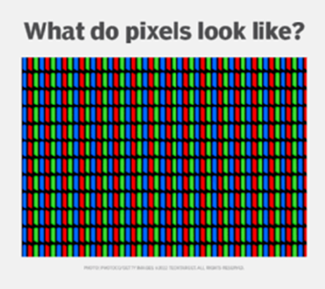A **pixel is the smallest unit of a digital image or display and stands for “picture element.”** It is a very small, isolated dot that stands for one color and plays the most basic part in digital images. Pixels when combined help to create the mosaic of colors and shapes contributing towards visual content being displayed on screens such as smartphones, computers TVs, etc. Every pixel in the image is marked by its coordinates and contains information about color and brightness.

**Fig 2. Pixel Representation**

**Resolution:** Resolution **means the number of little squares, called pixels, in a digital photo**. Usual measurements for resolution arefor pictures that get printed and pixels per centimeter (PPCM). For example, a screen that can show pictures at 1920 x 1080 has more tiny dots or pixels from left to right and has 1920 pixels horizontally and 1080 pixels vertically.

**7. Techniques of Image Processing**

**Image Acquisition**

* Image acquisition is the first step in image processing. This step is also known as preprocessing in image processing. It involves retrieving the image from a source, usually a hardware-based source.

**Image Enhancement**

* Image enhancement is the process of bringing out and highlighting certain features of interest in an image that has been obscured. This can involve changing the brightness, contrast, etc.

**Image Restoration**

* Image restoration is the process of improving the appearance of an image. However, unlike image enhancement, image restoration is done using certain mathematical or probabilistic models.

**Compression**

* Compression is a process used to reduce the storage required to save an image or the bandwidth required to transmit it. This is done particularly when the image is for use on the Internet.

**Morphological Processing**

* Morphological processing is a set of processing operations for morphing images based on their shapes.

**Segmentation**

* Segmentation is one of the most difficult steps of image processing. It involves partitioning an image into its constituent parts or objects.

**Feature Extraction**

* Edge Detection: Locating edges or boundaries within an image.
* Corner Detection: Identifying corner points which are stable under transformations.

**Representation and Description**

* After an image is segmented into regions in the segmentation process, each region is represented and described in a form suitable for further computer processing. Representation deals with the image’s characteristics and regional properties. Description deals with extracting quantitative information that helps differentiate one class of objects from the other.

**Recognition**

* Recognition assigns a label to an object based on its description.

**8. Operations on Images**

**Arithmetic Operations:**

Arithmetic operations on images in MATLAB involve manipulating pixel values directly or applying mathematical operations between images.

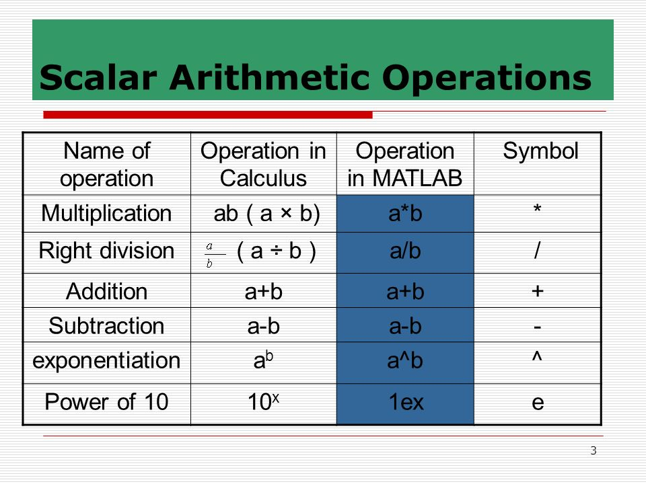

***Fig 3. Basic Arithmetic Operations***

1. Addition & Subtraction: You can add or subtract images pixel-wise. Ensure that both images have the same dimensions or are appropriately resized.
2. Multiplication & Division: Multiplication and division are also performed pixel-wise. These operations are useful for scaling or contrast adjustments.

* CLIPPING: Pixel values are automatically clipped to the valid range (0 to 255 for uint8 images) after arithmetic operations.

**Logical Operations:**

**AND, OR, XOR, NOT:** These operations are performed bitwise on corresponding pixels of two images or on a single image.

* **AND:** Results in an output where a pixel is true (white) only if both corresponding pixels in the input images are true (white).
* **OR:** Results in an output where a pixel is true (white) if at least one corresponding pixel in the input images is true (white).
* **XOR (Exclusive OR):** Results in an output where a pixel is true (white) if only one of the corresponding pixels in the input images is true (white).
* **NOT:** Inverts the pixels of a single input image.

**Thresholding:**

* **Binary Thresholding:** Converts a grayscale image into a binary image where pixels are either black or white based on a specified threshold value.
* **Multiple Thresholding:** Divides a grayscale image into multiple regions based on different threshold values, creating a multi-level binary image.

**Bitwise Operations:**

**Bitwise AND, OR, XOR:** These operations are performed at the bit level and are used for masking, combining, or modifying specific bits of pixel values.

**Comparison Operations:**

**Equal, Not Equal, Greater Than, Less Than:** These operations compare pixel values between images or against a threshold, resulting in a binary image where pixels satisfy the comparison condition.

These operations are foundational in image processing and are used for tasks such as image blending, masking, segmentation, and feature extraction. They manipulate pixel values based on mathematical or logical rules to achieve desired effects or to extract meaningful information from images. Each operation can be implemented efficiently using bitwise operations or using higher-level functions provided by image processing libraries and tools.

**Medical & Biological Image Processing**

Medical and biological image processing in MATLAB involves specialized techniques and tools tailored for analyzing and interpreting images from medical and biological contexts. 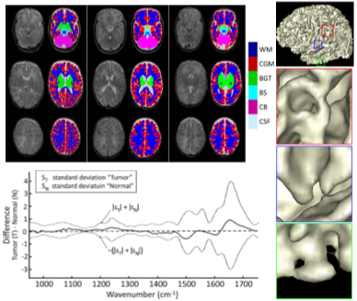

**Fig 4. Medical Image Processing**

* DICOM Support: Read and process medical images in DICOM format using functions like ‘dicomread’ & ‘dicominfo’.
* Cell counting & Analysis: Automate cell counting and analysis tasks using functions tailored for biological image processing.

**9.Applications of Image Processing**

Image processing finds applications across a wide range of fields, leveraging its ability to manipulate, analyze, and extract information from images. Here are specific applications in various domains:

**1. Medical Image Retrieval**

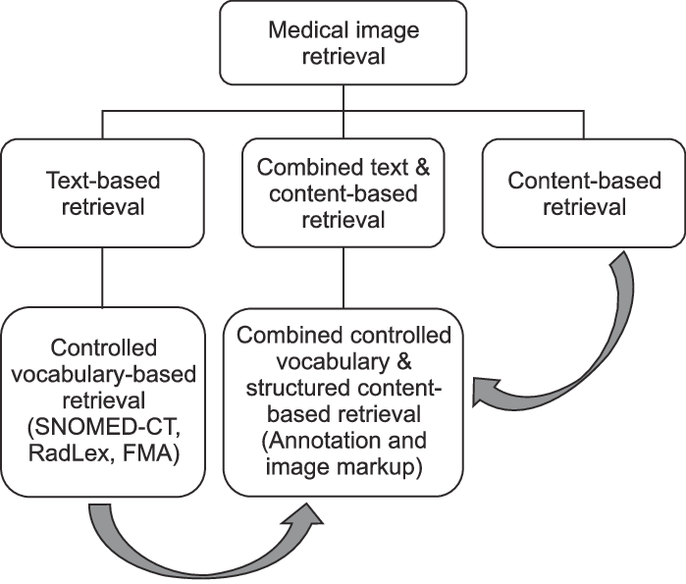

**Fig 5. Medical Image Retrieval**

Implementing medical image retrieval involves integrating these techniques with domain-specific knowledge of medical imaging modalities (such as MRI, CT, ultrasound) and pathologies (such as tumors, fractures, anomalies). It requires robust image processing algorithms, efficient database management, and often utilizes advanced machine learning and deep learning techniques for feature extraction and representation.Since medical usage calls for highly trained image processors, these applications require significant implementation and evaluation before they can be accepted for use.

**2. Remote Sensing**

Remote sensing refers to the process of acquiring information about an object or phenomenon without physically being in direct contact with it. This is typically done using sensors mounted on satellites, aircraft, drones, or ground-based platforms. Remote sensing technology captures data by detecting and measuring electromagnetic radiation (usually in the form of visible light, infrared, or microwave radiation) reflected or emitted from the Earth's surface and atmosphere.

* **Environmental Monitoring:** Analysis of satellite images for climate change, natural disasters.it has applications like land cover and land use mapping, Vegetation Monitoring, water quality assessment, wildlife monitoring, natural disaster management and many more.
* **Urban Planning:** Land use mapping, infrastructure development using aerial imagery for applications like Infrastructure planning and management, urban expansion and development, green space and parks planning, emergency management and disaster response, public transport and mobility planning.

**3. Security and Surveillance**

* **Video Surveillance:** Monitoring and analyzing video feeds for security purposes.
* **Object Detection:** Identifying and tracking objects in real-time video streams.

**4. Automotive Industry**

* **Autonomous Vehicles:** Image analysis for lane detection, obstacle avoidance. Image processing plays a vital role in enabling autonomous vehicles (AVs) to perceive and interact with their environment effectively. Estimating the distance to objects using stereo vision or depth-sensing cameras to avoid collisions, Identifying lane boundaries, markings, and lane curvature using image processing algorithms, recognizing and interpreting traffic signs, signals, and road markings for navigation and compliance with traffic laws.
* **Driver Assistance:** Warning systems for collision avoidance, pedestrian detection.

**5. Aeronautics**

Image processing plays a critical role in various applications within the field of aeronautics, where it helps enhance safety, efficiency, and capabilities in both civilian and military aviation.

**Aircraft Guidance and Navigation:**

* Terrain Recognition**:** Using image processing to identify and avoid terrain hazards during low-altitude flight or landing approaches.
* Runway Detection: Detecting and analyzing runway markings, lights, and obstacles to assist in precision landing and takeoff.

**Pilot Assistance Systems:**

* Head-Up Displays (HUDs): Overlaying critical flight information and navigation cues onto the pilot's view using augmented reality techniques.
* Enhanced Vision Systems (EVS): Providing pilots with enhanced visibility in low-visibility conditions (e.g., fog, darkness) using infrared or other imaging technologies.

**Aircraft Maintenance and Inspection:**

* Automated Inspection**:** Using image processing to detect and analyze defects, cracks, or abnormalities in aircraft structures and components.
* Damage Assessment**:** Assessing damage from bird strikes, hail, or other incidents to determine repair needs.

**Weather Monitoring and Forecasting:**

* Weather Radar Analysis**:** Processing radar images to monitor weather patterns, detect storms, and provide real-time weather updates to pilots and air traffic controllers.
* Cloud Detection: Identifying cloud formations and predicting their movement to aid flight planning and route optimization.

**10. Image Processing in MATLAB**

Image processing is a set of techniques for manipulating and analyzing 2D images and 3D volumes. Image Processing Toolbox lets you enhance, filter, denoise, register, and segment images and volumes. There is a procedure to do image processing in MATLAB which is as follows:

**Fig 6. Image Processing Block Diagram**

1. **Importing and Visualizing Images**

Import and visualize different image types in MATLAB. Manipulate images for streamlining subsequent analysis steps.

1. **Preprocessing Images**

Enhance images for analysis by using common preprocessing techniques such as contrast adjustment and noise filtering.

* Adjusting contrast
* Reducing noise with spatial filtering
* Equalizing inhomogeneous background
* Processing images in distinct blocks
* Measuring image quality

**c) Segmentation**

Improve binary segmentation results by refining the segmentation mask. Use interactive and iterative techniques to segment image regions.  
1. Using morphological operations to refine segmentation masks  
2. Segmenting images and refining results interactively  
3. Using iterative techniques to evolve segmentation from a seed  
  
 **d) Finding and Analyzing Objects**Count and label objects detected in a segmentation. Measure object properties like area, perimeter, and centroids.  
  
 **e) Detecting Edges and Shapes**Detect edges of objects and extract boundary pixel locations. Detect objects by shapes such as lines and circles.

**11. Brain Tumor Detection**

What is Brain Tumor?

A brain tumor is a growth of cells in the brain or near it. Brain tumors can happen in the brain tissue. Brain tumors also can happen near the brain tissue. Nearby locations include nerves, the pituitary gland, the pineal gland, and the membranes that cover the surface of the brain.  
Brain tumors can begin in the brain. These are called primary brain tumors. Sometimes, cancer spreads to the brain from other parts of the body. These tumors are secondary brain tumors, also called metastatic brain tumors.

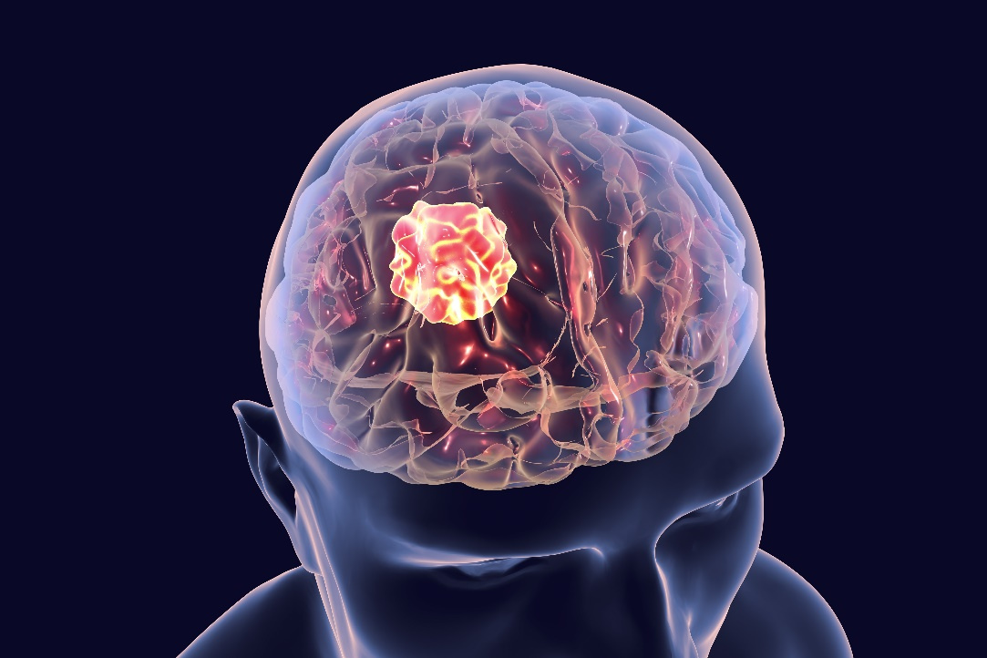

**Fig 7.Brain Tumor**

**Types of Brain Tumors**

Many different types of primary brain tumors exist. Some brain tumors aren't cancerous. These are called noncancerous brain tumors or benign brain tumors.   
Other brain tumors are brain cancers, also called malignant brain tumors. Brain cancers may grow quickly. The cancer cells can invade and destroy the brain tissue.

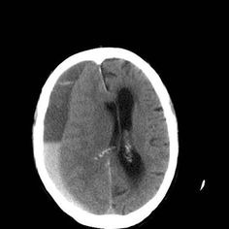 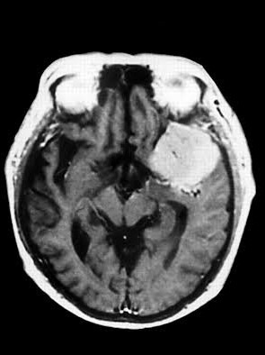

**Fig 8. No Tumor MRI Fig 9. Brain with Tumor MRI**

Brain tumors range in size from very small to very large. Some brain tumors are found when they are very small because they cause symptoms that you notice right away. Other brain tumors grow very large before they're found. Brain tumor treatment options depend on the type of brain tumor you have, as well as its size and location. Common treatments include surgery and radiation therapy.

**12. Brain Tumor Detection using Image Processing**

Among the various types of tumors, brain tumors are more dangerous and needs immediate medical attention. Hence there is a need for fast, automated, efficient and reliable technology for accurate detection of tumors. Usually, Doctors look at MRI images of the patient's brain to locate brain tumors manually. This leads to an inaccurate detection of tumors and is very time consuming. Various image processing techniques and the advancements in artificial intelligence have made the automatic detection of brain tumors easier.

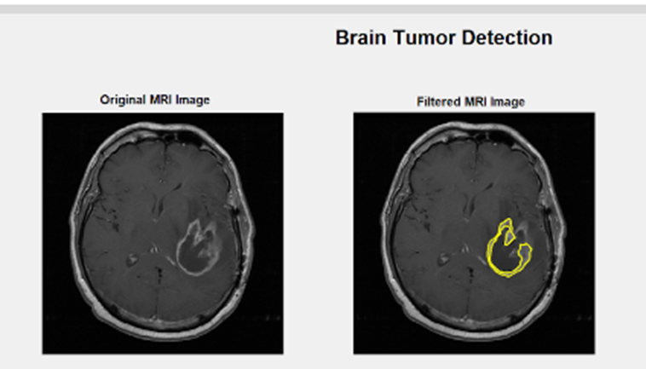

**Fig 9. Segmented Tumor**

For brain tumor detection in MATLAB the MRI images are pre-processed so that further morphological operations can be performed on these images for the detection of size, shape and location of tumor. Pre-processing of MRI images is done for noise removal and image enhancement while morphological operations are performed using MATLAB algorithms to separate and detect tumor in brain. The ultimate goal of segmentation is to extract important features from the image data. The segmentation of tumor from MRI images of brain is time consuming process. MATLAB is fast algorithm used for detection of tumor from MRI images in a very short time.

**13. MATLAB Code**

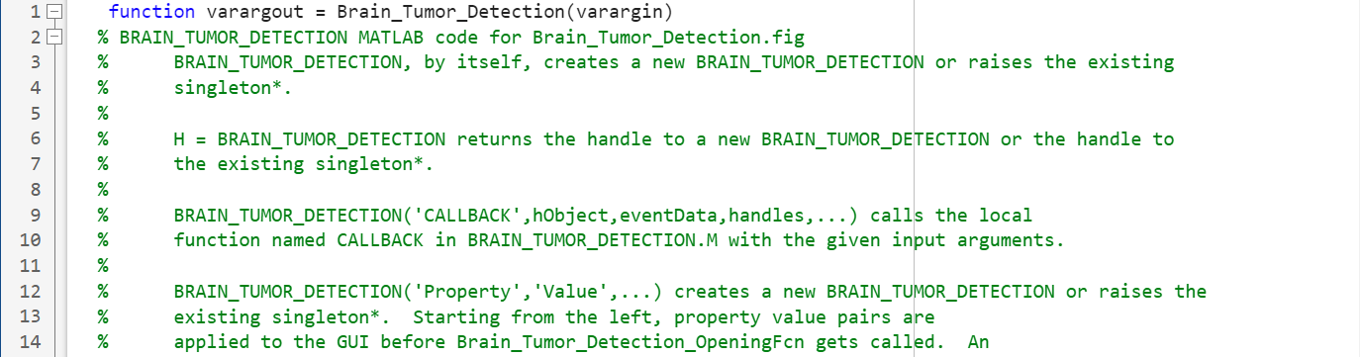 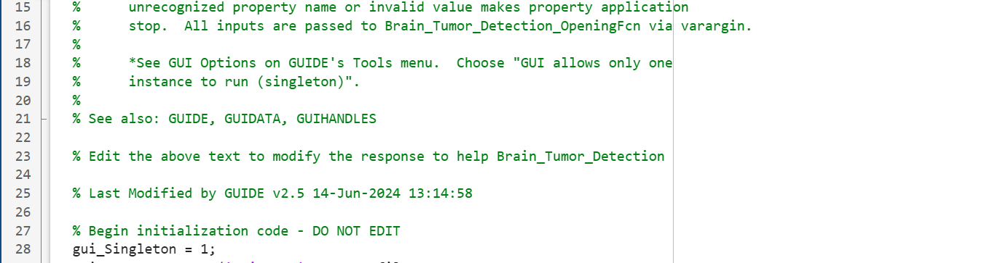 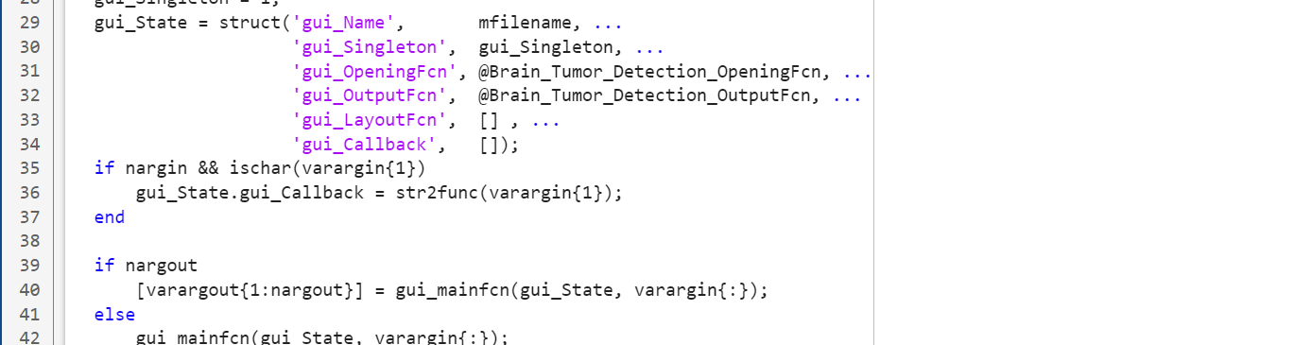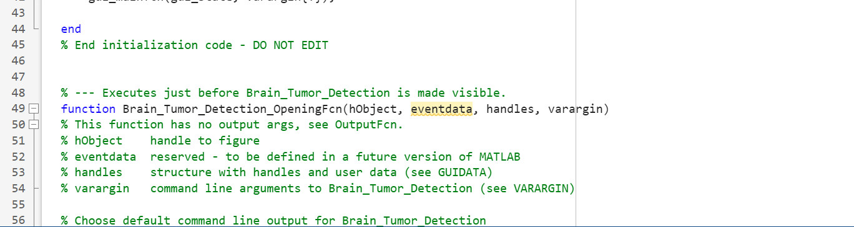 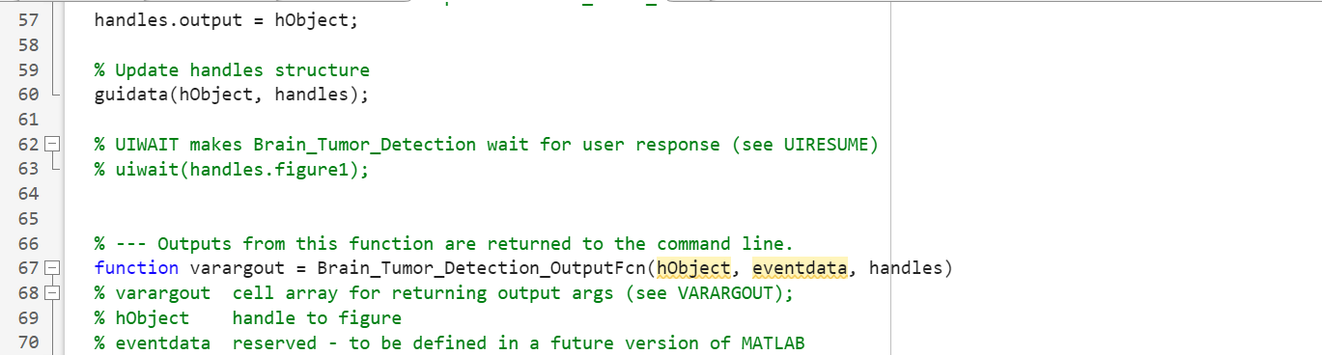 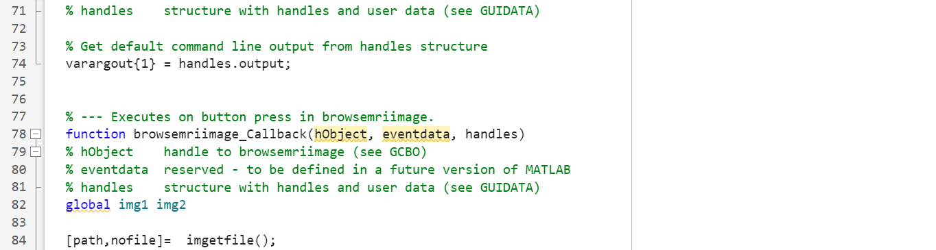 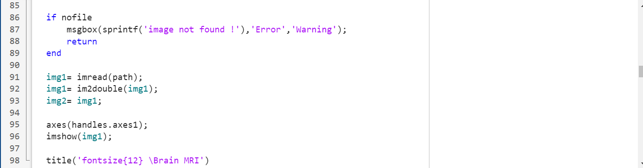 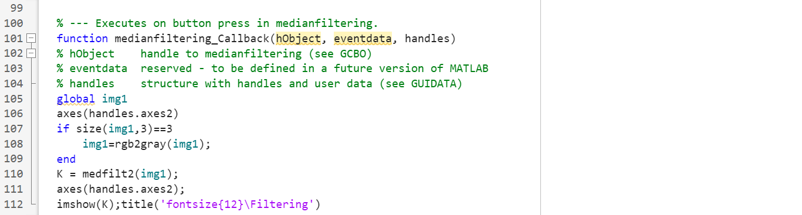 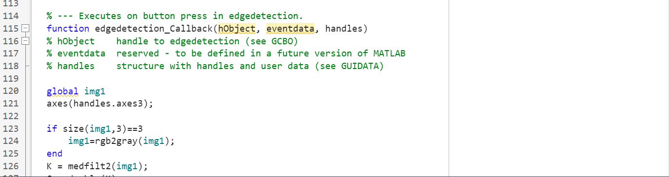 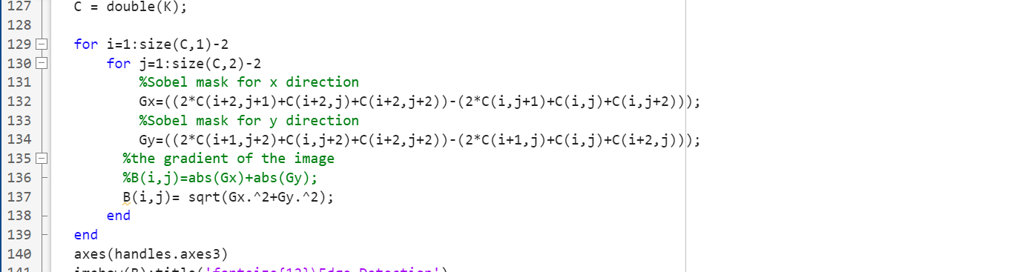 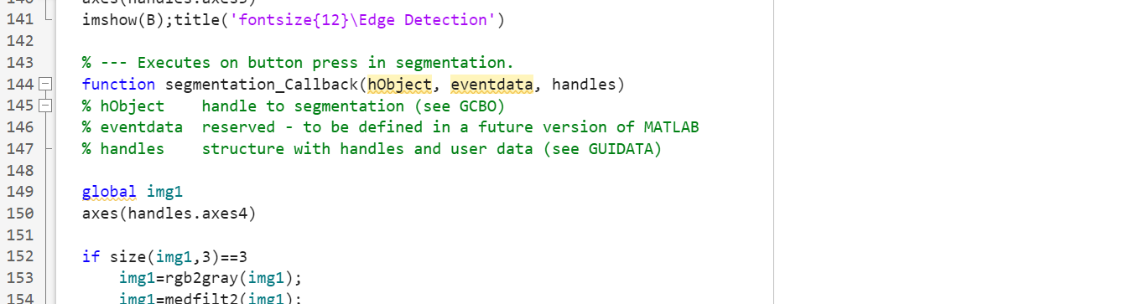 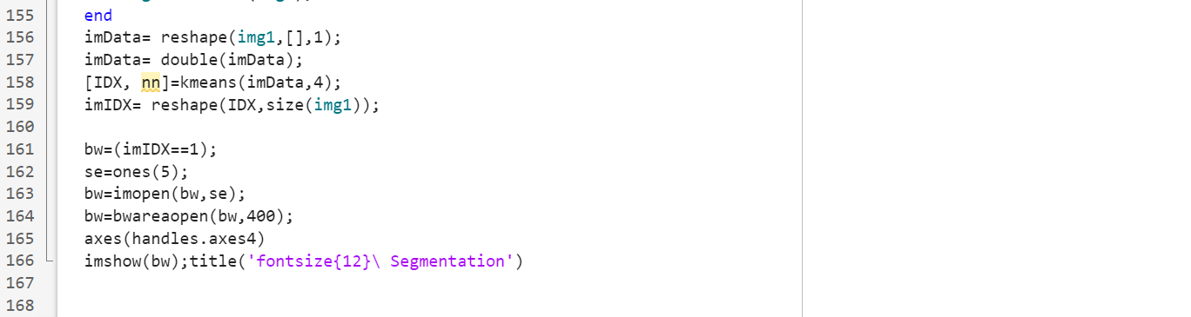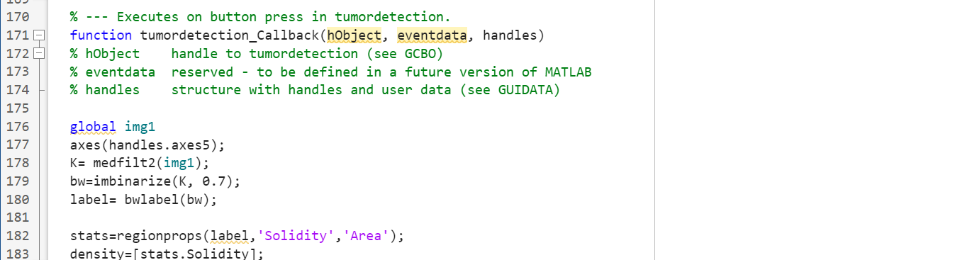

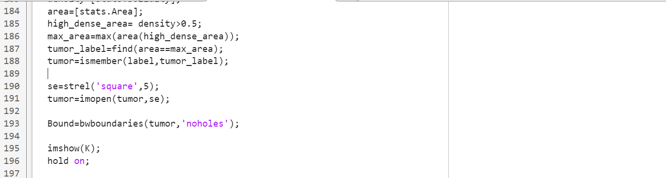 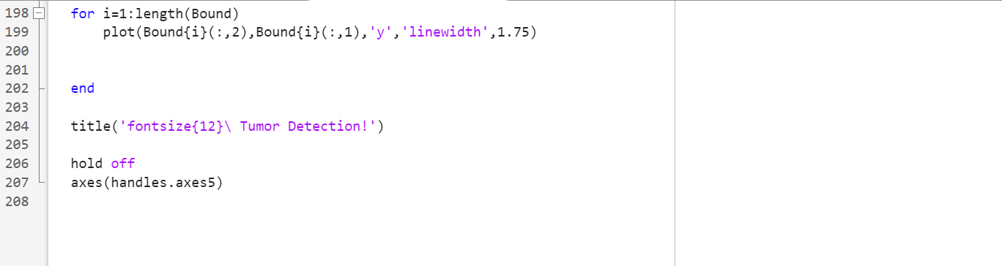

**14. PROCEDURE OF THE PROJECT**

1. Initiate Graphical User Interface (GUI).

2. Loading and Reading MRI Images in MATLAB.

3. Image Filtering using Median Filter.

4. Edge Detection using Sobel Filter.

5. Segmentation.

6. Detected Tumor.

**1. Initiate Graphical User Interface (GUI)**

The first step would be to create and initiate the graphical user interface, GUI. This could be done by typing guide into the command window, pressing enter, and creating a new GUI. Then functions such as axes, static text, edit text, and push buttons can be created that will be displayed once the program is run and the user can interact with. It is important to change the Tag name of each function that is implemented because it will allow us to create a distinguishable callback function. Once you are

satisfied with the layout of your GUI you can move on to loading the files that will be displayed within the GUI.

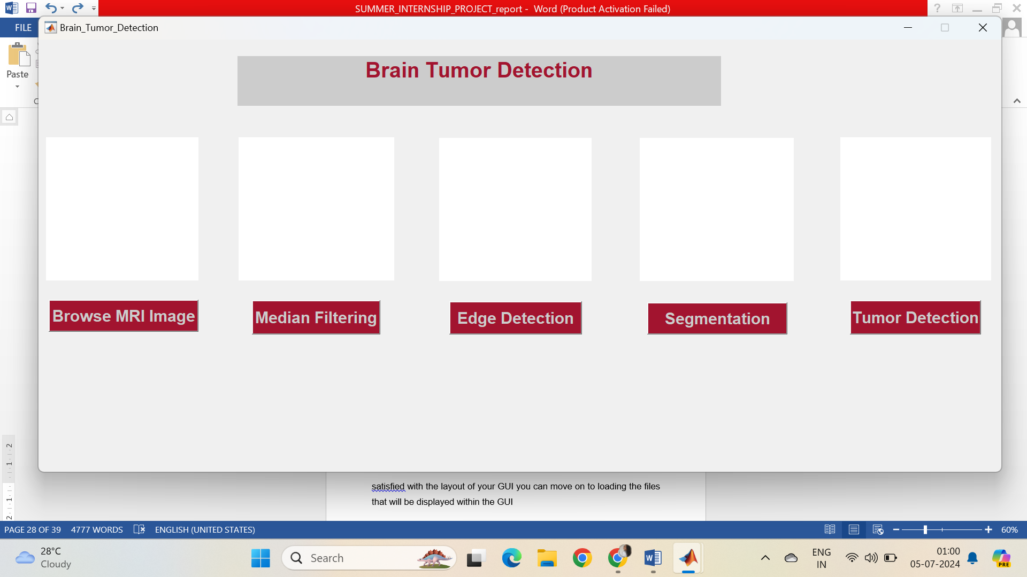

**Fig 11. GUI in MATLAB**

**2. Loading and Reading MRI Images in MATLAB**

1. In order to load the MRI files I correctly initialized the call back function that would be executed when pressing the button “Load MRI Image.”  
2. Once this is completed, a global variable is created that would display the image on the handles axes where I want the Original MRI Image to be displayed.   
3. Locate the file using imgetfile function in order to load them into the program. The images are read using the built in MATLAB function ‘imread’, and the first raw image for each file is imbedded into the left GUI axes using imshow function.  
4. We created variables for each of the descriptive information of the patients which will be used for the GUI when the detect button is pressed.

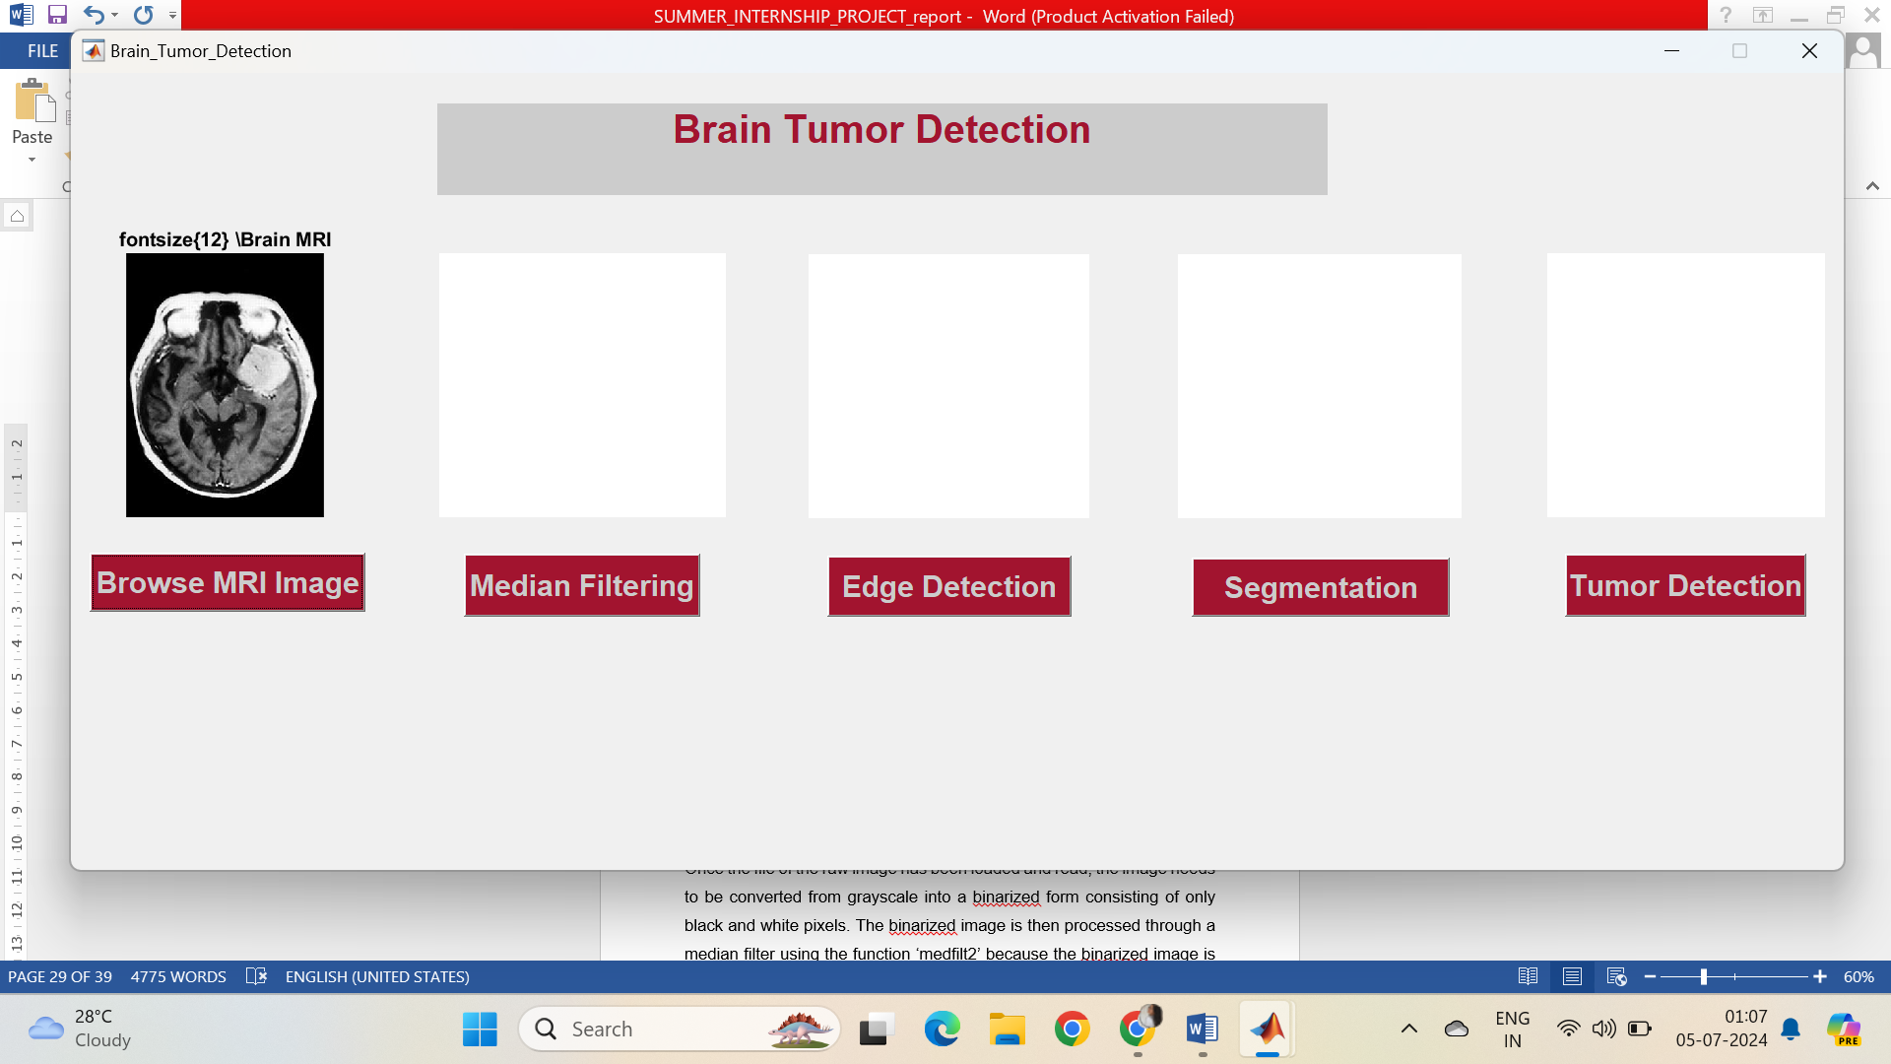

**Fig 12. Browsing image in GUI**

**3. Image Filtering using Median Filter**

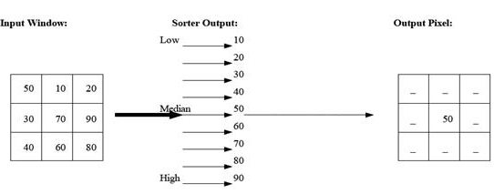

**Fig 13. Process of Median Filtering**

Once the file of the raw image has been loaded and read, use the medfilt2 function to apply a median filter to the image. This function replaces each pixel in the image with the median value in its neighborhood. Specify the size of the neighborhood as a parameter. I have used [3 3] matrix which specifies a 3x3 neighborhood (window size) for the median filter. You can adjust this parameter based on the level of noise in your image and the desired filtering effect. The medfilt2 function is versatile and can handle various neighborhood sizes ([M N]) for the median filter. Median filtering is effective for removing salt-and-pepper noise while preserving edges compared to other filters like Gaussian or mean filters.

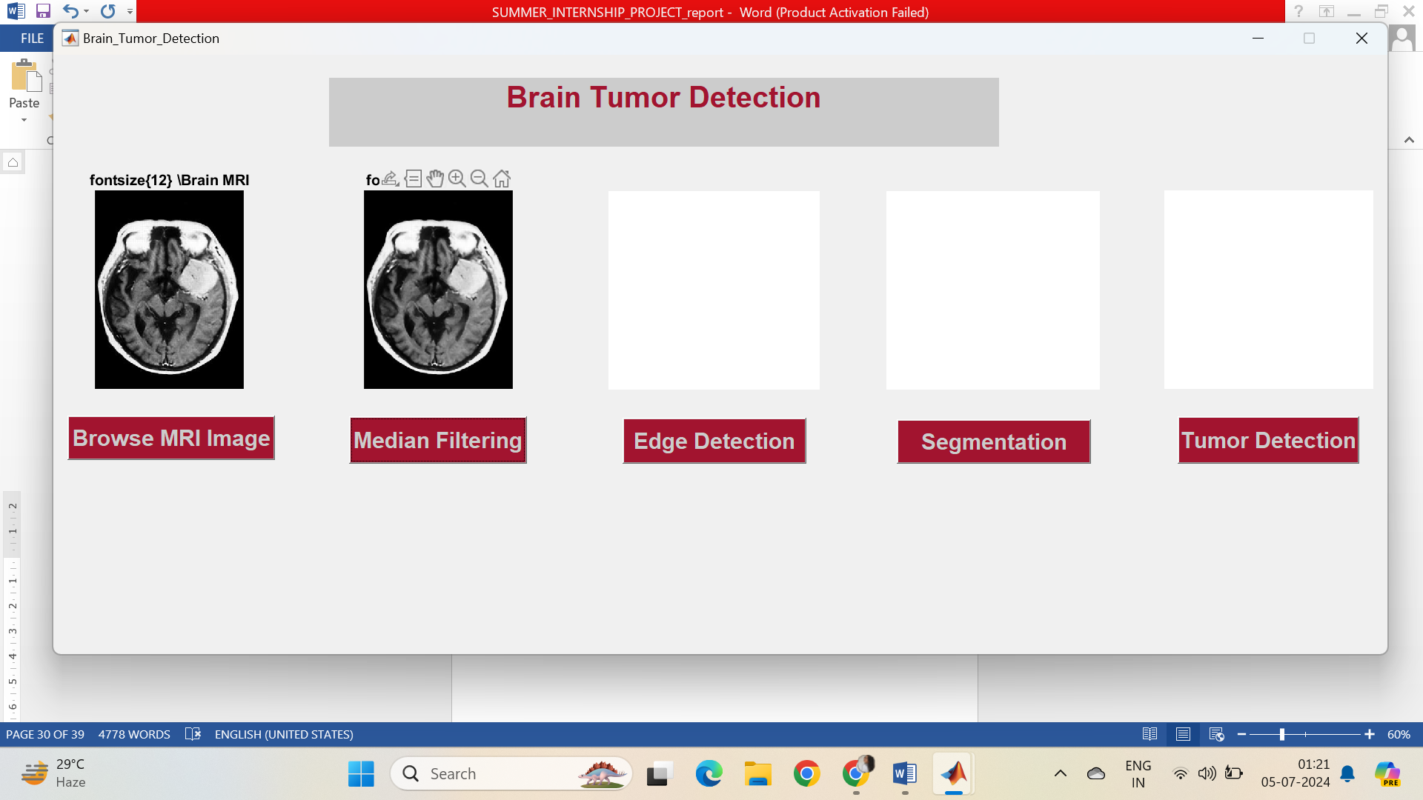

**Fig 14. Median Filtering in GUI**

**4. Edge Detection using Sobel Filter.**

Edge detection using the Sobel operator is a common technique in image processing, particularly for tasks like detecting boundaries or edges in medical images such as those of brain tumors.

1. First, load the medical image containing the brain tumor using ‘imread’ function. Convert the RGB image to Grayscale, as the sobel operator operates on grayscale.

2. Then use the edge function in MATLAB with the ‘Sobel’ method to perform edge detection.

3. Visualize the original image and the detected edges using imshow function.

By following these steps, you can implement edge detection using the Sobel operator in MATLAB for brain tumor detection, providing a foundation for more advanced image processing and analysis techniques in medical imaging.

The Sobel operator uses two 3x3 convolution kernels (one for horizontal changes and one for vertical changes) to calculate the gradient approximation of the image

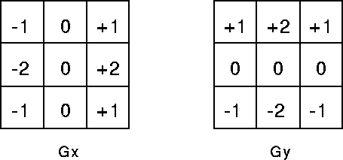

Here, Gx, computes the gradient in the horizontal direction (detects vertical edges), and Gy, ​ computes the gradient in the vertical direction (detects horizontal edges).

For each pixel in the image, the Sobel operator performs two convolutions: one with Gx and one with Gy. The resulting gradients Gx​ and Gy​ are combined to compute the magnitude of the gradient:

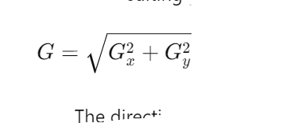

After computing the gradient magnitude GGG, a thresholding operation is typically applied to classify pixels as edge pixels (high gradient values) and non-edge pixels (low gradient values).

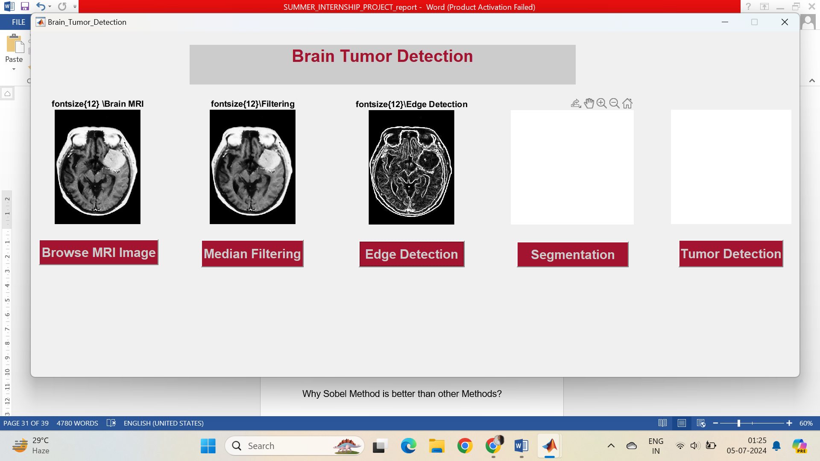

**Fig 15. Edge Detection in GUI**

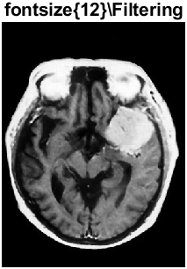 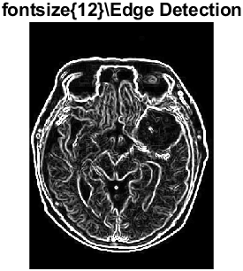

**Fig 17. Filtered Image Fig 18.Edge Detected Image**

**Advantages of Sobel Method:**

1. Directional Sensitivity:

The Sobel operator computes gradients in the horizontal and vertical directions separately. This directional sensitivity helps in detecting edges where there is a significant change in intensity along these directions. In medical images like brain scans, edges corresponding to tumor boundaries often exhibit such directional changes, making the Sobel operator effective for highlighting these edges.

2. Simplicity and Efficiency:

The Sobel operator is straightforward to implement and computationally efficient. It involves convolving the image with small, separable kernels (3x3 filters), which reduces computational complexity compared to more complex edge detection methods.

3. Noise Robustness:

The Sobel operator includes a smoothing effect due to the convolution with Gaussian-like kernels. This property helps in reducing the impact of noise in the image, which is common in medical imaging due to factors like equipment limitations or patient motion.

4. Gradient Magnitude Representation:

The Sobel operator computes the gradient magnitude, which represents the rate of change of intensity in the image. This representation is particularly useful for identifying edges with significant intensity variations, such as those present at tumor boundaries in medical images.

**5. Segmentation**

Segmentation in image processing refers to the process of partitioning an image into meaningful segments or regions based on certain criteria. MATLAB provides various tools and functions within its Image Processing Toolbox to perform segmentation tasks effectively.

**Types of Segmentation :**

1. Thresholding

* **Global Thresholding:** Divides an image into foreground and background based on a single global threshold value.
* **Adaptive Thresholding:** Uses local information to compute thresholds for different regions of the image, adapting to varying lighting conditions.

2. Region based Methods

* **Region Growing:** Starts from seed points and merges neighboring pixels or regions that have similar properties (e.g., intensity, color).
* **Region Splitting and Merging:** Divides regions based on uniformity criteria and then merges them to form meaningful segments.

3. Clustering based Methods

* **K-means Clustering:** Groups pixels into clusters based on similarity in intensity or color, aiming to minimize intra-cluster variance.
* **Mean Shift Clustering:** Iteratively shifts cluster centroids based on the density of pixels to find natural clusters in the image.

4. Watershed Segmentation

* **Watershed Transformation:** Treats the grayscale gradient of the image as a topographic map and segments it into catchment basins or watersheds.
* **Marker-Controlled Watershed:** Uses markers (seed points) to guide the segmentation process and prevent over-segmentation.

5. Contour-Based Segmentation

* **Active Contour (Snakes):** Deforms a contour to delineate object boundaries by minimizing an energy function related to image gradients.
* **Level Set Methods:** Evolves a level set function over time to detect object boundaries and segment regions based on level set zero-crossings.

**K-means Clustering**

K means clustering is used in this project for segmentation.

Using K-means clustering for brain tumor detection in MATLAB involves segmenting an image into clusters based on pixel intensities, with the aim of isolating tumor regions from surrounding healthy tissue.

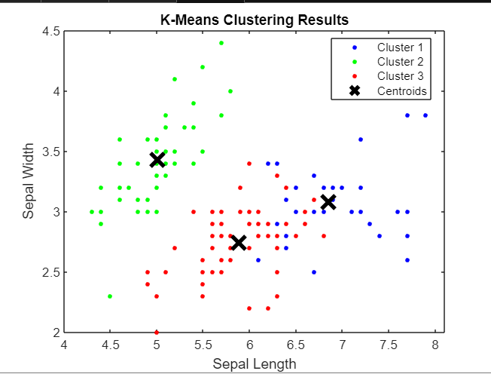

**Fig 19. K means Clustering**

1. For doing k means clustering we reshape the grayscale image into a vector format suitable for input to the k means function.
2. Then, Apply the K-means clustering algorithm to segment the image into clusters representing different tissue types (e.g., tumor and normal tissue).
3. Specify the number of clusters based on the expected number of regions in the image (e.g., 2 for tumor and healthy tissue).
4. Then, reshaping the clustered indices back into the original image dimensions to visualize the segmented regions.

 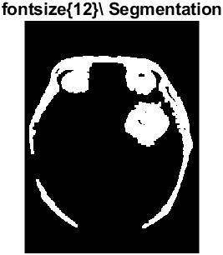

**Fig 20. Filtered Image Fig 21. Segmented Tumor**

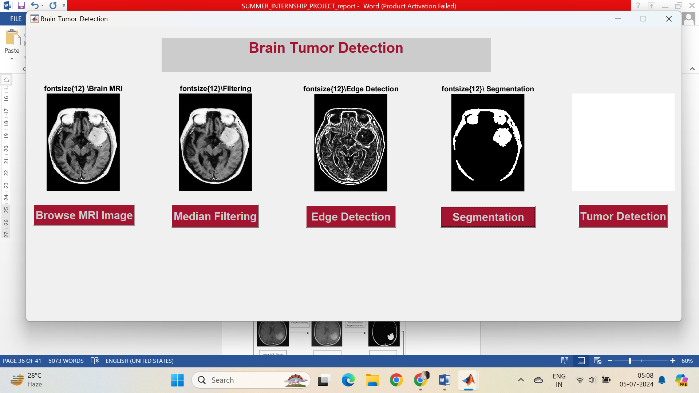

**Fig 22. Segmentation IN GUI**

**6. Detected Tumor**

After successful implementation of the procedure of image pre-processing, filtering, image segmentation using k means clustering, edge detection using Sobel method, and finally the tumor is detected. The final result of brain tumor detection using MATLAB typically involves providing actionable information regarding presence of tumor in brain.

Displaying the original medical image overlaid with segmented regions that indicate potential tumor areas. This helps visualize where the algorithm has identified abnormalities compared to healthy tissue.

Based on extracted features or classification algorithms, classify each segmented region as either tumor or non-tumor. This decision is often presented as a list or visual overlay on the original image.

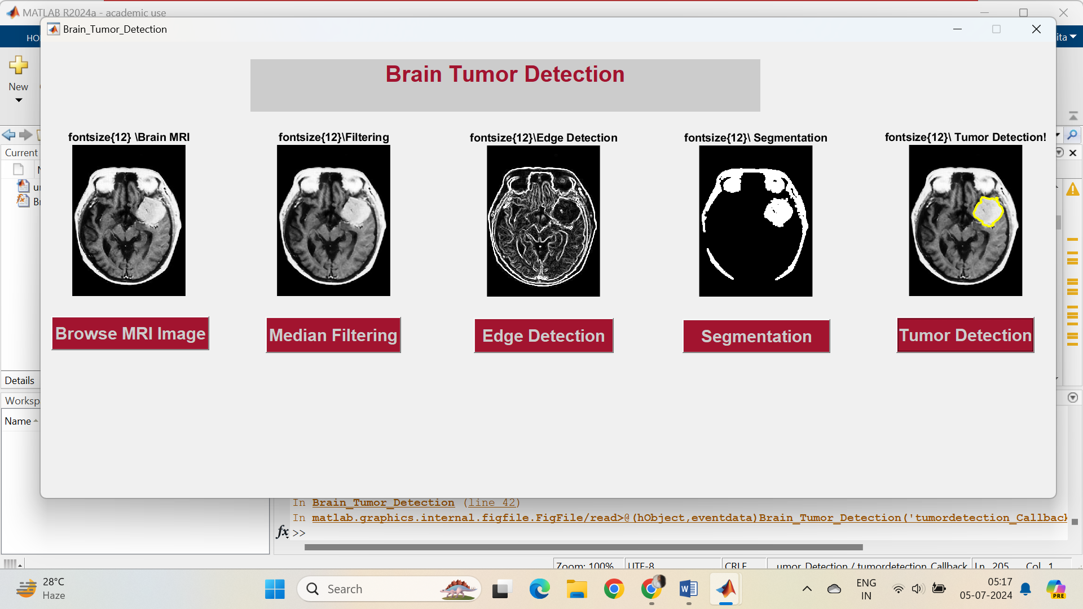

**Fig 23. Tumor Detection in GUi**

Here, finally the tumor is detected in the GUI using all the steps of image processing and hence tumor can be detected.

 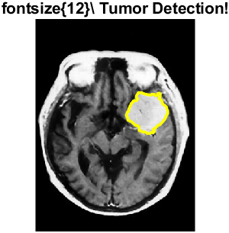

**Fig 24. Filtered Image Fig 25. Detected Tumor Image**

**15. Results**

We successfully detected the segmented tumor from the MRI of the brain and classified the type of tumor. We compared the results of our projects with that of the given datasets and calculated the accuracy of the detection algorithm we used, which turned out to be 93% accurate. Moreover, a comprehensive report is also prepared summarizing the findings, including images, the algorithm used, measurements, and diagnostic conclusions.

**12. REFERENCE**

1. W. Deng and W. Xiao, “MRI brain tumor segmentation based on improved fuzzy c-means method”, Sixth International Symposium on Multispectral Image Processing and Pattern Recognition, International Society for Optics and Photonics, (2009)
2. G. Padmavathi and M. Muthukumar, “Non linear image segmentation using fuzzy c-means clustering method with thresholding for underwater images”, IJCSI, vol. 7, no. 3, (2010), p. 35.
3. A. Mustaqeem and A. Javed, “An efficient brain tumor detection algorithm using watershed & thresholding based segmentation”, International Journal of Image, Graphics and Signal Processing, vol. 4, no. 10, (2012), p. 34.
4. R. C.Patil and A. Bhalchandra, “Brain tumour extraction from MRI images using MATLAB”, International Journal of Electronics, Communication and Soft Computing Science & Engineering (IJECSCSE), vol. 2, no. 1, (2012), p. 1.
5. D. Dilip Kumar, S Vandana, K. Sakhti Priya and S. Jeneeth Subhashini, "Brain Tumor Image Segmentation using MATLAB", *IJIRST*, vol. 1, no. 12, pp. 447-451, May 2015.

6. Riries Rulaningtyas and Khusnul Ain, "Edge Detection and Brain Tumor Pattern Recognition", *IEEE International Conference on Instrumentation Communication Information Technology and Biomedical Engineering*, pp. 23-25, Nov 2009.

7. Animesh Hazra, Ankit Dey, Sujit Kumar Gupta, Md.Abid Ansari,” Brain tumor detection based on segmentation using MATLAB”, IEEE International Conference on Energy, Communication, Data Analytics and Soft Computing(ICECDS).

8. <https://www.instructables.com/Brain-Tumor-MRI-Detection-Using-Matlab/>

9. <https://www.ncbi.nlm.nih.gov/pmc/articles/PMC9854739/>

10. <https://www.kaggle.com/datasets/masoudnickparvar/brain-tumor-mri-dataset>